

Space Race 3K
Friday, January 18, 2019
7:30 PM Start Time
Kennedy Space Center Visitor Complex
SR 405 – Kennedy Space Center, FL

Amenities

- Complimentary race shirt (Guaranteed shirt size by January 4, 2019)
- The walk/run guides participants through the historic Rocket Garden featuring eight authentic rockets, the booster stack that graces the entryway to Space Shuttle Atlantis® and by Heroes & Legends with a larger-than-life portrait of the Mercury 7 astronauts.
- Enjoy a beer or wine in the Rocket Garden at the after-race party.
- This family-friendly event is open to guests* of runners with a suggested donation of $5

Fees
Until 12/31/18 1/1/19-1/17/19 Race Day
3K $30.00 $35.00 $40.00
Guest Spectator* Donations Suggested for United Way
(*Not participating in the 3K Walk/Run)

SORRY, NO REFUNDS

Register Online at secure.runningzone.com

The Space Race is a 3K walk/run throughout Kennedy Space Center Visitor Complex that benefits United Way of Brevard.
Timetable

Thursday, January 17th, 2019
10:00 AM – 6:30 PM: Early Packet Pickup & Registration
Running Zone - 3696 N Wickham Rd, Melbourne

Friday, January 18, 2019
5:00 PM: Registration, Packet Pickup, & Guest Spectator Check-in Opens
7:15 PM: Registration, Packet Pickup, & Guest Spectator Check-in Closes
7:30 PM: 3K Start
8:15 PM: Awards Ceremony/Post Race After Party

Awards
Top 3 M & F Age Groups:
14 & under 15-19 20-24 25-29
30-34 35-39 40-44 45-49
50-54 55-59 60-64 65-69
70-74 75 & over
Winners in each category will receive their award from a veteran NASA astronaut!

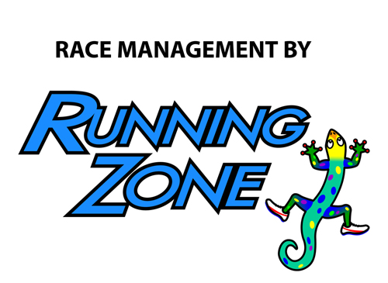

Space Race 3K - OFFICIAL ENTRY

Send completed entry form with fee to: Running Zone, 3696 N. Wickham Rd., Melbourne, FL 32935

Make check payable to: United Way of Brevard

First _________________________________________ Last_________________________________________

Sex: Male Female Date of Birth _______/_______/_______ Age on Race Day _______

Address __________________________City ____________________________State _______ Zip _________

Phone ____________________________ Email address ____________________________________________

Shirt Size: S M L XL XXL

INCOMPLETE OR UNSIGNED ENTRY FORMS WILL NOT BE ACCEPTED
In consideration of my entry being accepted, I intend to be legally bound, and hereby for myself, my heirs, and executors, waive all rights and claims for damages which may hereafter accrue to me against the sponsors, officials, volunteers, and supporters of this race and any representatives, successors, or assigns for any and all damages or injuries which may be sustained and suffered by me in consideration of my association with an entry or participation in the Space Race 3K Walk/Run event. If I should suffer injury or illness, I authorize the officials of the race to use their discretion to have me transported to a medical facility, and I take full financial and legal responsibility for this action. I attest and verify that I am physically fit and have my physician’s permission to participate in this race. I hereby grant full permission to any and all of the foregoing to use any photographs, videotapes, or any other record of this event for any purpose of the event whatsoever. I have read the above release and understand that it presents a risk of physical injury, knowing this I am entering this event at my own risk.

________________________________________ ___________________________________________ __________
SIGNATURE SIGNATURE OF PARENT FOR THOSE UNDER 18 DATE

_______________________________________ ___________________
Signature (parent or guardian if under 18 Date

