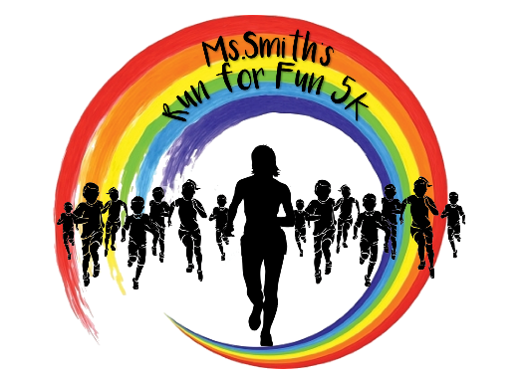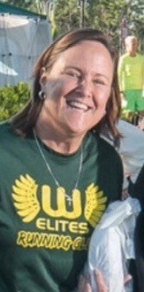Ms. Smith’s Run for Fun 5K

Saturday, November 3rd, 2018

4:30 PM – 5K Start

Fred Poppe Regional Park

1951 Malabar Road, Palm Bay

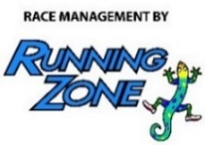

***To Benefit:***

*Westside Elites Running Club*

**Time Table:**

**Friday, November 2nd, 2018:** ***Running Zone***

(3696 N. Wickham Rd, Melbourne)

10 AM-6:30 PM: Early Packet Pickup and Registration

**Saturday, November 3rd, 2018:** ***Fred Poppe Regional Park –*** (1951 Malabar Road,Palm Bay)

3:15 PM: Registration & Packet Pickup Opens

4:15 PM: Registration Closes

4:30 PM: 5K Start!

***\* Awards Ceremony Following 5K***

**Awards:**

M-F: Top 3 Overall, Top Masters (40+),

Age Groups (Top 3 M-F):

8 & Under 25-29 50 -54 75-79

9-11 30-34 55 -59 80+

12-14 35-39 60 -64

15-19 40 -44 65 - 69

20-24 45-49 70 -74

**Race Amenities:**

* Cool T-shirts (**Guaranteed shirt size if registered by October 15)
* Awesome Awards
* Food & Beverage after the race

**Fees: Through 11/2 Race Day**

Adult $25 $30

Child (12 & under) $15 $20

**SORRY, NO REFUNDS.**

Register Online at [*secure.runningzone.com*](https://secure.runningzone.com/)

**Ms. Smith’s Run for Fun 5K - Official Entry**

Mail entry form with fee to: *Running Zone - 3696 N. Wickham Rd, Melbourne, FL 32935*

**Make check payable to: Westside Elementary PTO**

First: ______________________________________________ Last: _______________________________________________

Sex:  Male  Female Date of Birth: ______ /_______ /________ Age on Race Day: _________

Email: ______________________________________________________ Phone: _____________________________________

Address: ________________________________ City: _______________________________ State: ________ ZIP: _________

T-Shirt Size:  Youth Small  Youth Medium  Youth Large  Small  Medium  Large  XLarge  XXLarge

INCOMPLETE OR UNSIGNED ENTRY FORMS WILL NOT BE ACCEPTED

In consideration of my entry being accepted, I intend to be legally bound, and hereby for myself, my heirs, and executors, waive all rights and claims for damages which may hereafter accrue to me against the sponsors, officials, volunteers, and supporters of this race and any representatives, successors, or assigns for any and all damages or injuries which may be sustained and suffered by me in consideration of my association with an entry or participation in the Ms. Smith’s Run for Fun 5K event. If I should suffer injury or illness, I authorize the officials of the race to use their discretion to have me transported to a medical facility, and I take full financial and legal responsibility for this action. I attest and verify that I am physically fit and have my physician’s permission to participate in this race. I hereby grant full permission to any and all of the foregoing to use any photographs, videotapes, or any other record of this event for any purpose of the event whatsoever. I have read the above release and understand that it presents a risk of physical injury, knowing this I am entering this event at my own risk.

_____________________________________ _________________________________________________ _____________________ SIGNATURE SIGNATURE OF PARENT/GUARDIAN (FOR THOSE UNDER 18) DATE