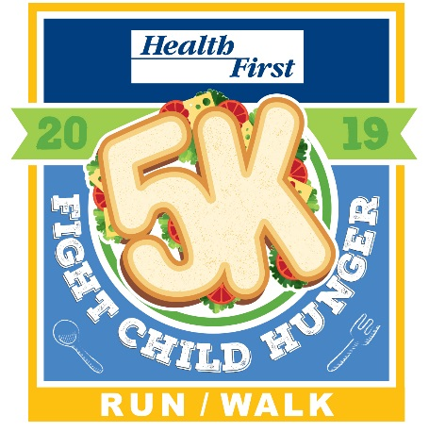**Fight Child Hunger 5K**

**Run/Walk**

**Saturday, January 12th, 2019**

***FREE pancake breakfast for all participants***!

*8:00 AM START*

Viera High School

 6103 Stadium Parkway, Melbourne

*Bring the whole family out for a fun morning and help raise awareness of the efforts to fight childhood hunger by* ***The Children’s Hunger Project and the Sharing Center of Central Brevard.***

*To learn more visit:* *www.fightchildhunger5k.org*

***All participants will receive a pancake breakfast after the race!***

**AWARDS:**

Top 3 Teams (min. of 5 people w/ at least one of opposite sex)

Top School Participation

M-F: Top 3 Overall, Top Masters (40+),

Age Groups (Top 3 M-F):

8 & Under 25 – 29 50 – 54 75—79

9 – 11 30 – 34 55 – 59 80+

12 – 14 35 – 39 60 – 64

15 – 19 40 – 44 65 – 69

20 – 24 45 – 49 70 – 74

Top School Participation

M-F: Top 3 Overall, Top Masters (40+),

Age Groups (Top 3 M-F):

8 & Under 25 – 29 50 – 54 75—79

9 – 11 30 – 34 55 – 59 80+

12 – 14 35 – 39 60 – 64

15 – 19 40 – 44 65 – 69

20 – 24 45 – 49 70 – 74

**FEES: Until 1/11 Race Day (1/12)**

Adults $25 $30

Youth 12 & under $15 $20

***Sorry, No Refunds.***

**TIMETABLE:**

**Friday, January 11th – 10:00 AM – 6:30 PM**

Packet Pickup & Registration at ***Running Zone***

(3696 N. Wickham Rd, Melbourne)

**Saturday, January 12th – Viera High School**

(6103 Stadium Parkway, Melbourne)

6:45 AM Packet Pickup & Registration Opens

7:45 AM Late Registration for 5K Ends

8:00 AM 5K Run Start*

*\*Awards ceremony immediately follows race.*

***Fight Child Hunger 5K* OFFICIAL 5K ENTRY FORM**

Send completed entry form to: Running Zone - 3696 N Wickham Rd, Melbourne, FL 32935

Make check payable to: **Fight Child Hunger 5K**

First __________________________________ Last_____________________________________

Address ___________________________City __________________________ State _______ Zip __________

Email address ____________________________________ Phone _________________________

Sex:  Male  Female Date of Birth _______/_______/_______ Age on Race Day __________

School: ___________________________________________________

Team Name: ________________________________________________ (min. of 5 people w/ at least one of opposite sex)

Shirt Size:  YM  S  M  L  XL  XXL

**INCOMPLETE OR UNSIGNED ENTRY FORMS WILL NOT BE ACCEPTED**

In consideration of my entry being accepted, I intend to be legally bound, and hereby for myself, my heirs, and executors, waive all rights and claims for damages which may hereafter accrue to me against the sponsors, officials, volunteers, and supporters of this race and any representatives, successors, or assigns for any and all damages or injuries which may be sustained and suffered by me in consideration of my association with an entry or participation in the Fight Child Hunger 5K event. If I should suffer injury or illness, I authorize the officials of the race to use their discretion to have me transported to a medical facility, and I take full financial and legal responsibility for this action. I attest and verify that I am physically fit and have my physician’s permission to participate in this race. I hereby grant full permission to any and all of the foregoing to use any photographs, videotapes, or any other record of this event for any purpose of the event whatsoever. I have read the above release and understand that it presents a risk of physical injury, knowing this I am entering this event at my own risk.

_____________________________________ _________________________________________________ _____________________

SIGNATURE SIGNATURE OF PARENT/GUARDIAN (FOR THOSE UNDER 18) DATE

**Presented by:**