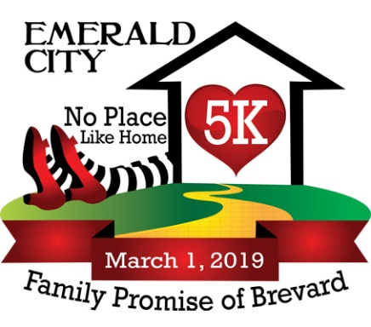**No Place Like Home 5K**

Friday, March 1st, 2019

***6:00 PM – 5K Start***

Church at Viera

9005 N. Wickham Rd., Viera

**Awards**

Best race-themed costume contest!

Fastest costume award!

Top 3 Teams (min. of 4 - must be co-ed)

Top 3 Overall M & F, Top Masters M & F,

Top 3 M & F in Age Groups:

8 & Under, 9-11, 12-14, 15-19, 20-24, 25-29, 30-34, 35-39,

40-44, 45-49, 50-54, 55-59, 60-64, 65-69, 70-74, 75-79,80+

**Directions:**

From I-95, take Wickham Rd west to Stadium Parkway, Church at Viera is on the left.

**Race Amenities**

* Music & Local Vendors
* Games
* Raffles
* Race-Themed Costume Contest and Awards!
* Race Shirts - ***guaranteed if registered by 2/14***

**Time Table**

**Thursday, February 28th** - *Running Zone*

3696 N. Wickham Rd., Melbourne, FL 32935

10:00 AM - 6:30 PM: Packet Pickup & Registration

**Friday, March 1st** - *Church at Viera*

9005 N. Wickham Rd., Viera, FL 32940

4:45 PM: Packet Pickup & Late Registration Opens

5:45 PM: Packet Pickup & Late Registration Closes

6:00 PM: 5K START!

7:15 PM: Kids Run!!!

*Awards immediately following race

**No Place Like Home 5K - OFFICIAL REGISTRATION FORM**

**Make Checks Payable to**: Family Promise of Brevard

**Mail to:** Family Promise of Brevard, PO Box 562666, Rockledge FL 32956

First: _____________________________________ Last: ________________________________________

Address: ________________________________ City: __________________ State: ____ Zip: __________

Sex:  Male  Female Age on Race Day: _____________ DOB: _____/_______/_______

Phone Number: ___________________________ Email Address: _________________________________

Shirt Size:  Youth Medium  Youth Large  Small  Medium  Large  XL  XXL

Team Name: _______________________________________________________ (Min. of 4 - must be co-ed)

**Additional Donation: $1.00___ $3.00___ $5.00___ $10.00___ $________ (Fill in $ Amount)**

**INCOMPLETE OR UNSIGNED ENTRY FORMS WILL NOT BE ACCEPTED**

In consideration of my entry being accepted, I intend to be legally bound, and hereby for myself, my heirs, and executors, waive all rights and claims for damages which may hereafter accrue to me against the sponsors, officials, volunteers, and supporters of this race (series) and any representatives, successors, or assigns for any and all damages or injuries which may be sustained and suffered by me in consideration of my association with an entry or participation in the No Place Like Home 5K. If I should suffer injury or illness, I authorize the officials of the race to use their discretion to have me transported to a medical facility, and I take full financial and legal responsibility for this action. I attest and verify that I am physically fit and have my physician’s permission to participate in this race. I hereby grant full permission to any and all of the foregoing to use any photographs, email, videotapes, or any other record of this event for any purpose of the event whatsoever. I have read the above release and understand that it presents a risk of physical injury, knowing this I am entering this event at my own risk.

__________________________________________________________________ _____________________________________________

Signature (or Guardian of those under 18) Date

**Your contribution/participation helps end family homelessness in Brevard County by providing families the support and resources they need to put themselves on a path towards long-term housing stability. Family Promise of Brevard is a tax-exempt 501(c)(3) nonprofit organization. Your gift is tax-deductible as allowed by law.**

**Race Fees Until 2/28/19 Race Day**

Adult Reg. $25 $30

Child Reg. (12 & under) $15 $20

***Rain or Shine.*** ***Sorry, No Refunds!***