

WIZARDS, MAGIC, & MORE
A Harry Potter themed 5K Race
37th Downtown Melbourne 5K Run/Walk
Saturday, March 23, 2019

NEW CO-ED START @ 7:30 AM

New Wizardly Race House Start on the corner Municipal Lane between

New Haven and Strawbridge

(900 E New Haven Ave, Melbourne)


CALLING ALL WIZARDS, SORCERERS, & FRIENDS

It's time to bust out your running shoes, your finest house colors, and maybe brush up your best spells for the Downtown Melbourne’s Harry Potter-themed 5K Run/Walk!!

Do you believe in magic?? I DO!!

The magic happens when a community comes together to support each other!

Registration Timetable:
- Online at https://secure.runningzone.com/ until March 21st at 11:59 pm
- In Person at Running Zone on Wickham Road (between Parkway and Post Road)
- By mail to Running Zone (3696 N Wickham Road, Melbourne, FL 32935)
- Checks payable to The Haven
- Packet Pickup & Registration - Friday, March 22nd from 10:00 am to 6:30 pm at Running Zone (3696 N Wickham Road, Melbourne, FL 32935)
- Race Day Packet Pick-Up & Registration begins at 6:30am at New Wizardly Race House Start on the corner of Municipal Lane between New Haven and Strawbridge

Information:
- ViMarie Monopoli – Email: vimarie@thehavenforchildren.com
- Frank Webbe - Email: webbe@fit.edu

Proceeds benefit THE HAVEN

The race benefits The Haven, a shelter for abused, abandoned and neglected children.
Space Coast Runners Youth Series
The Space Coast Runners Youth Series aims to include youth in organized runs so as to encourage participation and interest in running and fitness. There will be no charge for these runs, but parents will be required to sign a waiver for their children to participate on the morning of the race. Distances: 1/4 mile, 1/2 mile, & 1 mile.
School Challenge
All children under the age of 18 may register for a special reduced fee of $20. The School (public or private) that has the most registrations for the 5K will earn a special award to be presented at the results following the races.
Open Team Challenge

All teams must have a minimum of 4 members. The fastest team in each category will receive an awards: Overall fastest All Male, All Female, and Co-Ed.

Awards
Male-Female: Top 3 Overall, Top Masters (40+), Grand Masters (50+), Senior Grand Masters (60+)
Each Race – Top 3 Teams, Age Groups (top 3 male & female): 10 & Under, 11-14, 15-19, 20-24, 25-29, 30-34, 35-39, 40-44, 45-49, 50-54, 55-59, 60-64, 65-69, 70-74, 75-79, 80-84, 85+
Fees: $25 until March 21st
$20 for students 18 & under until 3/21

($22 for SCR & Gecko Club Members until 3/21)
$30 March 22nd & Race Day

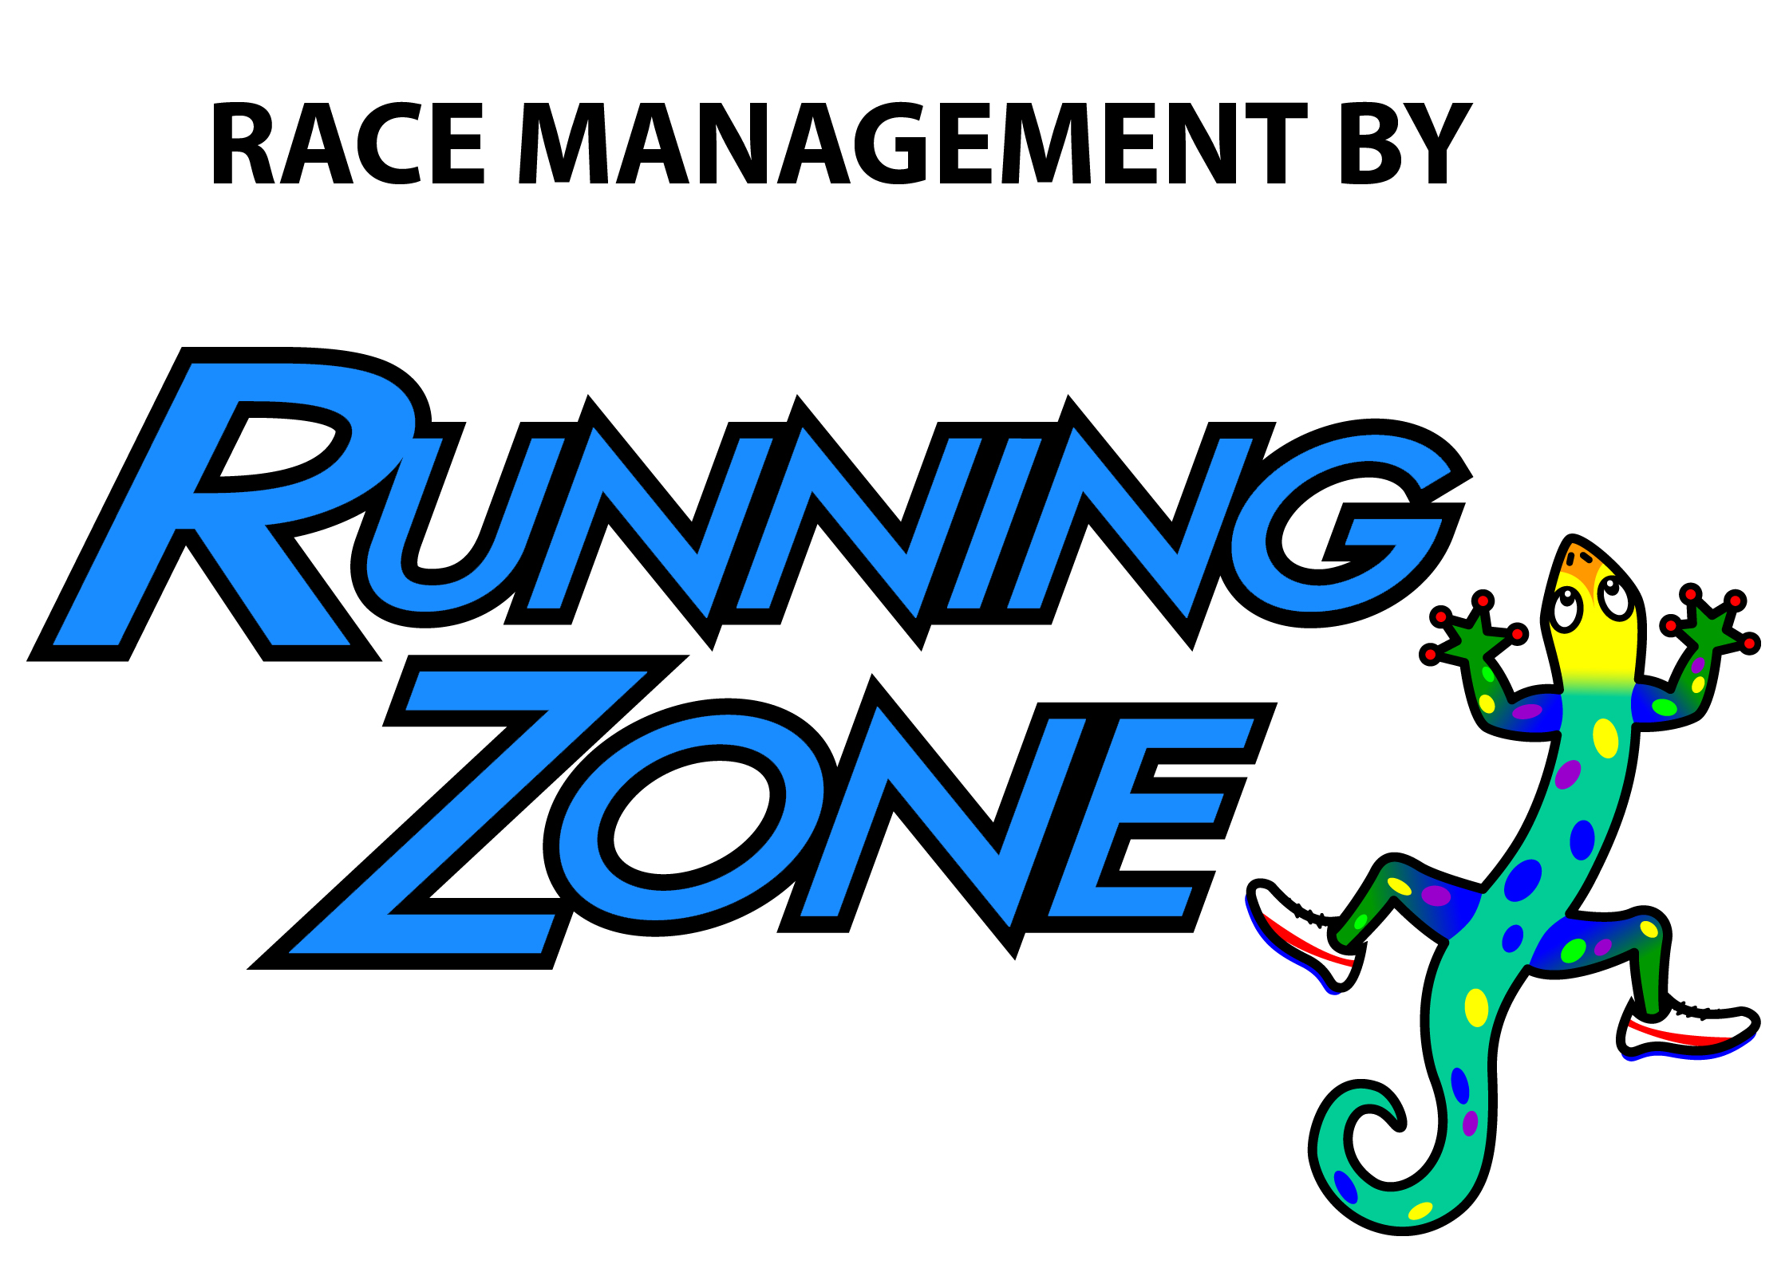

2019 DOWNTOWN MELBOURNE 5K OFFICIAL ENTRY FORM
Make checks payable to: The Haven Mail to: Running Zone, 3696 N Wickham Road, Melbourne, FL 32935

__________________________________________ __________________________________________
Last Name (Please print) First Name

________________________________________ ______________________________ ______ ________ ______________
Address City State ZIP Telephone

______________________ ____/____/______ ________ M__ F__ Y__ N__
Email Date of Birth Age on Race Day Gender Space Coast Runners Member?

T-shirt Size: Youth __ Adult S__ Adult M__ Adult L__ Adult XL__ Adult XXL__

Open Team Challenge Name __________________________________________________________________ (if applicable, see above for details)

School Participation Challenge (K-12) _____________________________________________

I assume all risks associated with running in this event including, but not limited to: falls, contact with other participants, the effects of the weather, including high heat and/or humidity, traffic and the conditions of the road, all such risks being known and appreciated by me. I grant permission to all of the foregoing to use any photographs, motion pictures, and recording, or any other record of this event for any legitimate purpose. Having read this waiver and knowing these facts and in consideration of you accepting my entry, I, for myself and anyone entitled to act on my behalf, waive and release The Haven, Space Coast Runners, Running Zone Race Management, Inc., the City of Melbourne and all sponsors, their representatives and successors from all claims or liabilities of any kind arising out of my participation in this event even though that liability may arise out of negligence or carelessness on the part of the persons named in this waiver. I have read the above release and understand that I am entering this event at my own risk.

______________________________________ _______________________________________________ ____________
SIGNATURE SIGNATURE OF PARENT FOR THOSE UNDER 18 DATE

