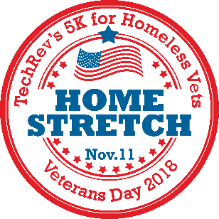
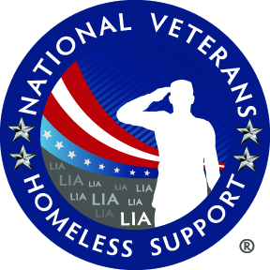

“HOME STRETCH”
5K Race to Benefit
National Veterans Homeless Support
Sunday, November 11, 2018 - Race begins at 8:00AM
Field of Dreams Park- West Melbourne, FL
Home Stretch 5K for Homeless Vets
OFFICIAL ENTRY FORM
Make check payable to: TechRev
Mail completed entry form to: The Running Zone, 3696 N. Wickham Road, Melbourne, FL 32935

First: _________________________________________ Last:______________________________________
Address: ____________________________ City: _______________________ State:______ Zip:_______
Email address: ___________________________________________ Phone: ______________________
Sex: Male Female Date of Birth: _______/_______/_______ Age on Race Day: ________
Team Name: __________________________ (Minimum of 5 Team Members)

Shirt Size (circle): YM YL YXL Adult S Adult M Adult L Adult XL Adult XXL

INCOMPLETE OR UNSIGNED ENTRY FORMS WILL NOT BE ACCEPTED
In consideration of my entry being accepted, I intend to be legally bound, and hereby for myself, my heirs, and executors, waive all rights and claims for damages which may hereafter accrue to me against the sponsors, officials, volunteers, and supporters of this race and any representatives, successors, or assigns for any and all damages or injuries which may be sustained and suffered by me in consideration of my association with an entry or participation in the TechRev’s Home Stretch 5K for Homeless Vets event. If I should suffer injury or illness, I authorize the officials of the race to use their discretion to have me transported to a medical facility, and I take full financial and legal responsibility for this action. I attest and verify that I am physically fit and have my physician’s permission to participate in this race. I hereby grant full permission to any and all of the foregoing to use any photographs, videotapes, or any other record of this event for any purpose of the event whatsoever. I have read the above release and understand that it presents a risk of physical injury, knowing this I am entering this event at my own risk.

________________________________ ____________________________________________ _______________________
SIGNATURE SIGNATURE OF PARENT FOR THOSE UNDER 18 DATE

Register online at: www.runsignup.com/homestretch SORRY, NO REFUNDS.
To Benefit:
National Veterans Homeless Support
“Eliminating homelessness among veterans in Central Florida”
NVHS is a community-based organization formed by veterans with the goal of locating and assisting the 1,300 and more homeless veterans that are currently living in the parks, woods, and streets and to get them off the streets permanently.
Packet Pickup & Registration @ Running Zone
3696 North Wickham Road, Melbourne, FL

Friday, November 9th – 10:00 AM – 6:30 PM
Saturday, November 10th – 10:00 AM – 5:00 PM

Race Day @ Field of Dreams Park
3053 Fell Road, West Melbourne, FL

Sunday, November 11th – Timeline:
6:30 AM Packet Pickup & Registration
7:45 AM Late Registration for 5k ends
8:00 AM 5K Start
AWARDS: (Immediately following the race)
M-F: Top 3 Overall, Top Masters (40+), Largest Team (1), Top Team (1) and Age Groups (Top 3 M-F):
8 & Under 25 - 29 50 – 54 75-79
9 – 11 30 – 34 55 – 59 80+
12 – 14 35 – 39 60 – 64
15 – 19 40 – 44 65 – 69
20 – 24 45 – 49 70 – 74

Participant Perks:
- Cool Tech Race Shirt (1st 250 runners)
- Pre-Race Snacks (Hemingway’s)
- Finisher Medals
- Award Medals
- Park and Face Paint for Kids
FEES: Until 11/8 11/9- Race Day
Adult $25 $30
Children (0-17) $20 $25
Military $15 $20
(Active Duty/Veteran)
Team $20 $25

