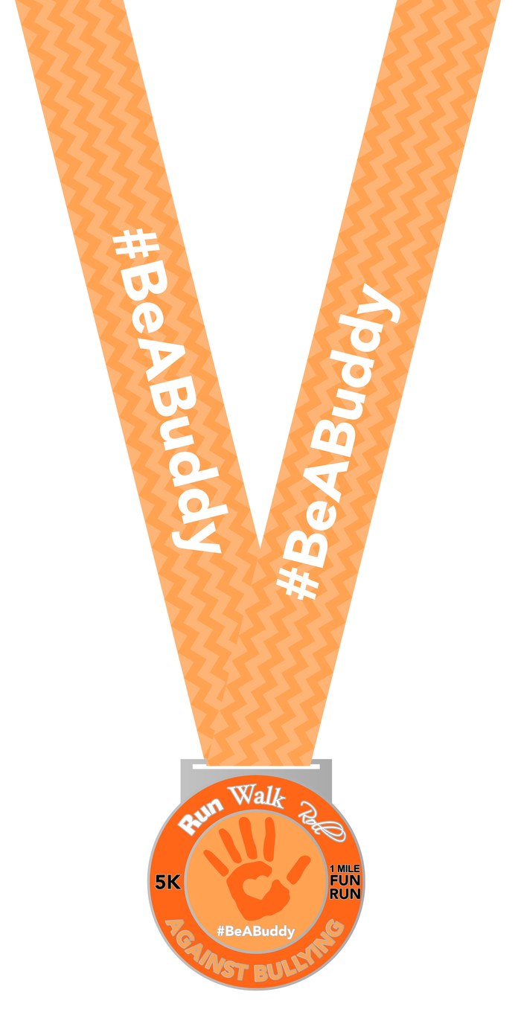

#Be A Buddy
Run Walk Roll Against Bullying 5K

Visit www.theparkerfoundation.com
for more information

Saturday, October 13th, 2018

8:00 AM Start

Wickham Park Amphitheater

To Benefit: The Parker Foundation and Bullying Prevention in Brevard County
The Parker Foundation provides free resources to children with Autism Spectrum Disorders (ASD) and related disabilities and their families through funding education, sports and arts programs. Our #BeABuddy 5K celebrates National Bullying Prevention Month, empowers our Peer Buddy Program, and unites the community in a campaign to keep all youth safe from bullying.
TIME TABLE:
Friday, October 12th 10:00 am – 6:30 pm
Packet Pickup & Registration at Running Zone
(Wickham Road just south of the King Center)

Saturday, October 13th – Wickham Park
Wickham Park Amphitheater - 2500 Parkway Drive, Melbourne, FL 32935
6:30 am Packet Pickup & Registration
7:45 am Late Registration for 5k ends
8:00 am 5k Start
9:15 am Free Kids Run will begin!
*Awards Ceremony immediately following the race
PRIZES: Largest Youth Team, Most Spirit, and More!

AWARDS:
M-F: Top 3 Overall, Top Masters (40+), Top Team (1) and Age Groups (Top 3 M-F):
8 & Under 25 - 29 50 – 54 75-79
9 – 11 30 – 34 55 – 59 80+
12 – 14 35 – 39 60 – 64
15 – 19 40 – 44 65 – 69
20 – 24 45 – 49 70 – 74

Run Walk Roll Against Bullying 5K OFFICIAL ENTRY FORM
Make check payable to: The Parker Foundation
Mail completed entry form to: The Running Zone, 3696 N. Wickham Road, Melbourne, FL 32935

First: __________________________________________Last:______________________________________
Address: ____________________________ City: ___________________________State:______ Zip: _______
Email address: ___________________________________________ Phone: _______________________
Sex: ⁮ Male ⁮ Female Date of Birth: ________/________/________ Age on Race Day: ________
Team Name: __________________________ (Minimum of 5 Team Members)

Shirt Size (circle): YM YL YXL Adult S Adult M Adult L Adult XL Adult XXL

INCOMPLETE OR UNSIGNED ENTRY FORMS WILL NOT BE ACCEPTED
In consideration of my entry being accepted, I intend to be legally bound, and hereby for myself, my heirs, and executors, waive all rights and claims for damages which may hereafter accrue to me against the sponsors, officials, volunteers, and supporters of this race and any representatives, successors, or assigns for any and all damages or injuries which may be sustained and suffered by me in consideration of my association with an entry or participation in the Run Walk Roll Against Bullying 5K event. If I should suffer injury or illness, I authorize the officials of the race to use their discretion to have me transported to a medical facility, and I take full financial and legal responsibility for this action. I attest and verify that I am physically fit and have my physician’s permission to participate in this race. I hereby grant full permission to any and all of the foregoing to use any photographs, videotapes, or any other record of this event for any purpose of the event whatsoever. I have read the above release and understand that it presents a risk of physical injury, knowing this I am entering this event at my own risk.

________________________________ ____________________________________________ _______________________
SIGNATURE SIGNATURE OF PARENT FOR THOSE UNDER 18 DATE

RACE AMENITIES:
- Cool Technical Race Shirt
- Finisher Medals
- Post-Race Fitness Expo
- Post-Race Local Food and Beverages
- Win Prizes

FEES: Until 10/5 10/6 - Race Day
5K Run/Walk $30.00 $35.00
Students $20.00 $20.00
Kids Run (8 and under) FREE FREE

Register online at secure.runningzone.com

SORRY, NO REFUNDS

