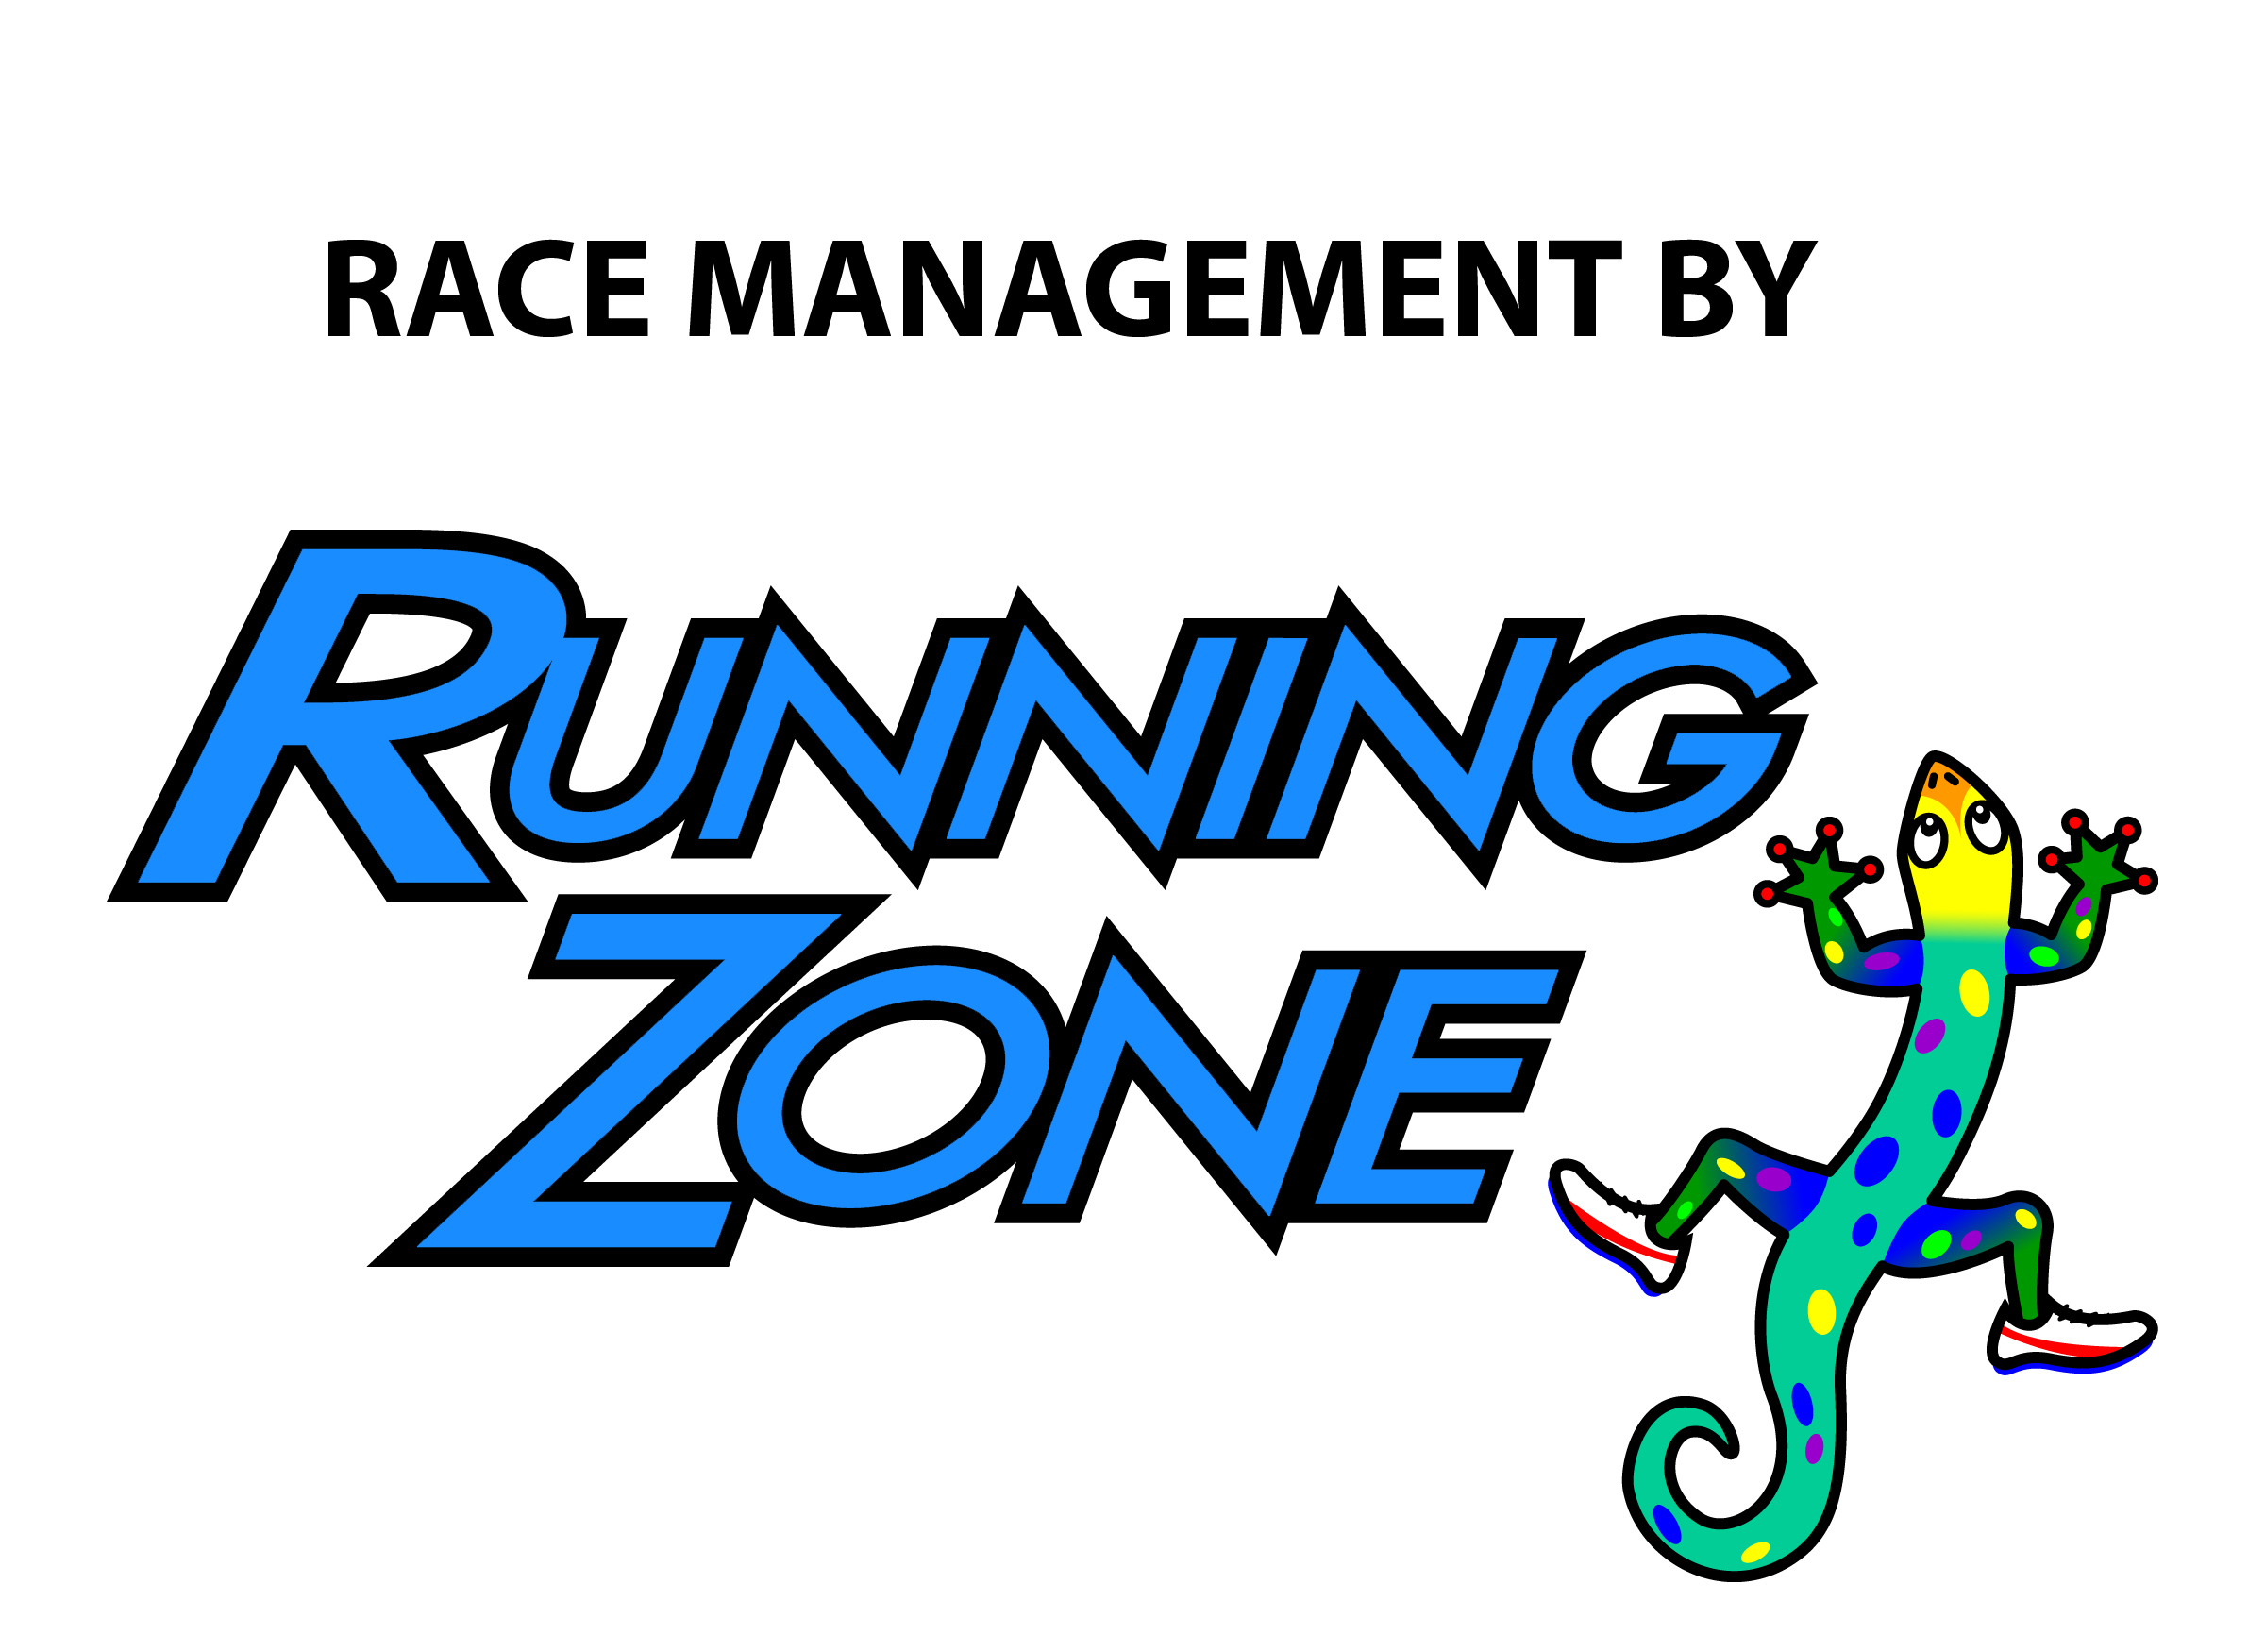
Amenities:
- T-shirts
- Door prizes (must be present to win)
- Fun Race Packets
- Food and Refreshments

Mustang Trot 5k
& Football Frenzy Fun Run
Sunday, October 4th
@ 7:30am
Thomas Jefferson Middle School
1275 S. Courtenay Pkwy.
Merritt Island, FL 32952


www.MerrittIslandPopWarner.com

TIMETABLE:
Packet Pickup and Registration at Running Zone
3696 N Wickham Road, Melbourne, FL 32935
Friday, October 2nd (10am-6:30pm) &
Saturday, October 3rd (10am-5pm)

Sunday, October 4th
Thomas Jefferson Middle School
1275 S. Courtenay Pkwy., Merritt Island, FL 32952
6:30 am Packet Pickup & Registration
7:15 am Registration Ends
7:30 am 5k Start!!!
*Awards ceremony immediately after race

Register online: www.secure.runningzone.com/mustang

- Register Online at https://secure.runningzone.com/
- Or Complete Reg Form and turn into Running Zone or mail to 3696 N Wickham Rd Melbourne, FL 32935

FEES:
5k Run/Walk Registration $25.00
Student Registration $20.00
5k Run/Walk Day-of Registration $30.00

Awards:
Male & Female: Top 3 Overall,
Top Masters (Age 40+),
Top 3 Male & Female in Age Groups
8 & Under 20-24 40-44 60-64
9-11 25-29 45-49 65-69
12-14 30-34 50-54 70-74
15-19 35-39 55-59 75+

MUSTANG TROT 2015 REGISTRATION FORM
OFFICIAL ENTRY FORM- Checks payable to M.I.S.A.

Name_______________________________________________

Address ____________________________________________

City _________________________________ State _______ Zip ______

Phone (daytime) __________________ Email address ____________________________________________

Date of Birth _____/_____/_____ Age on Race Day _______ Sex ☐ Male ☐ Female

Please check shirt size ☐YM ☐YL ☐S ☐M ☐L ☐XL ☐XXL

INCOMPLETE OR UNSIGNED ENTRY FORMS WILL NOT BE ACCEPTED
I intend to be legally bound and do hereby for myself, my heirs, and executor, waive all rights and claims for damage which may occur to me against Merritt Island Pop Warner Organization, Running Zone Race Management, Inc. and other named organizations of this event, or any subsidiary or political division thereof, its officers, agents, successors, representatives, assigns from all claims and liabilities of any kind that may arise from the Mustang Trot event though that liability may arise out of negligence or carelessness on behalf of the persons on this waiver. If I should suffer injury or illness, I authorize officials of the race to use their discretion to have me transported to a medical facility. I hereby grant full permission to any and all of the foregoing to use any photographs, videotapes, or any other record of this event for any purpose of the event whatsoever. I have read the above release and understand that it presents a risk of physical injury; knowing this, I am entering this event at my own risk.

______________________________________ ________________________________________________ ____________________
SIGNATURE SIGNATURE OF PARENT FOR THOSE UNDER 18 DATE
Send completed forms with fee to:
Running Zone
Attn: Mustang Trot
3696 N. Wickham Rd.
Melbourne, FL 32935

